Daily Opener: 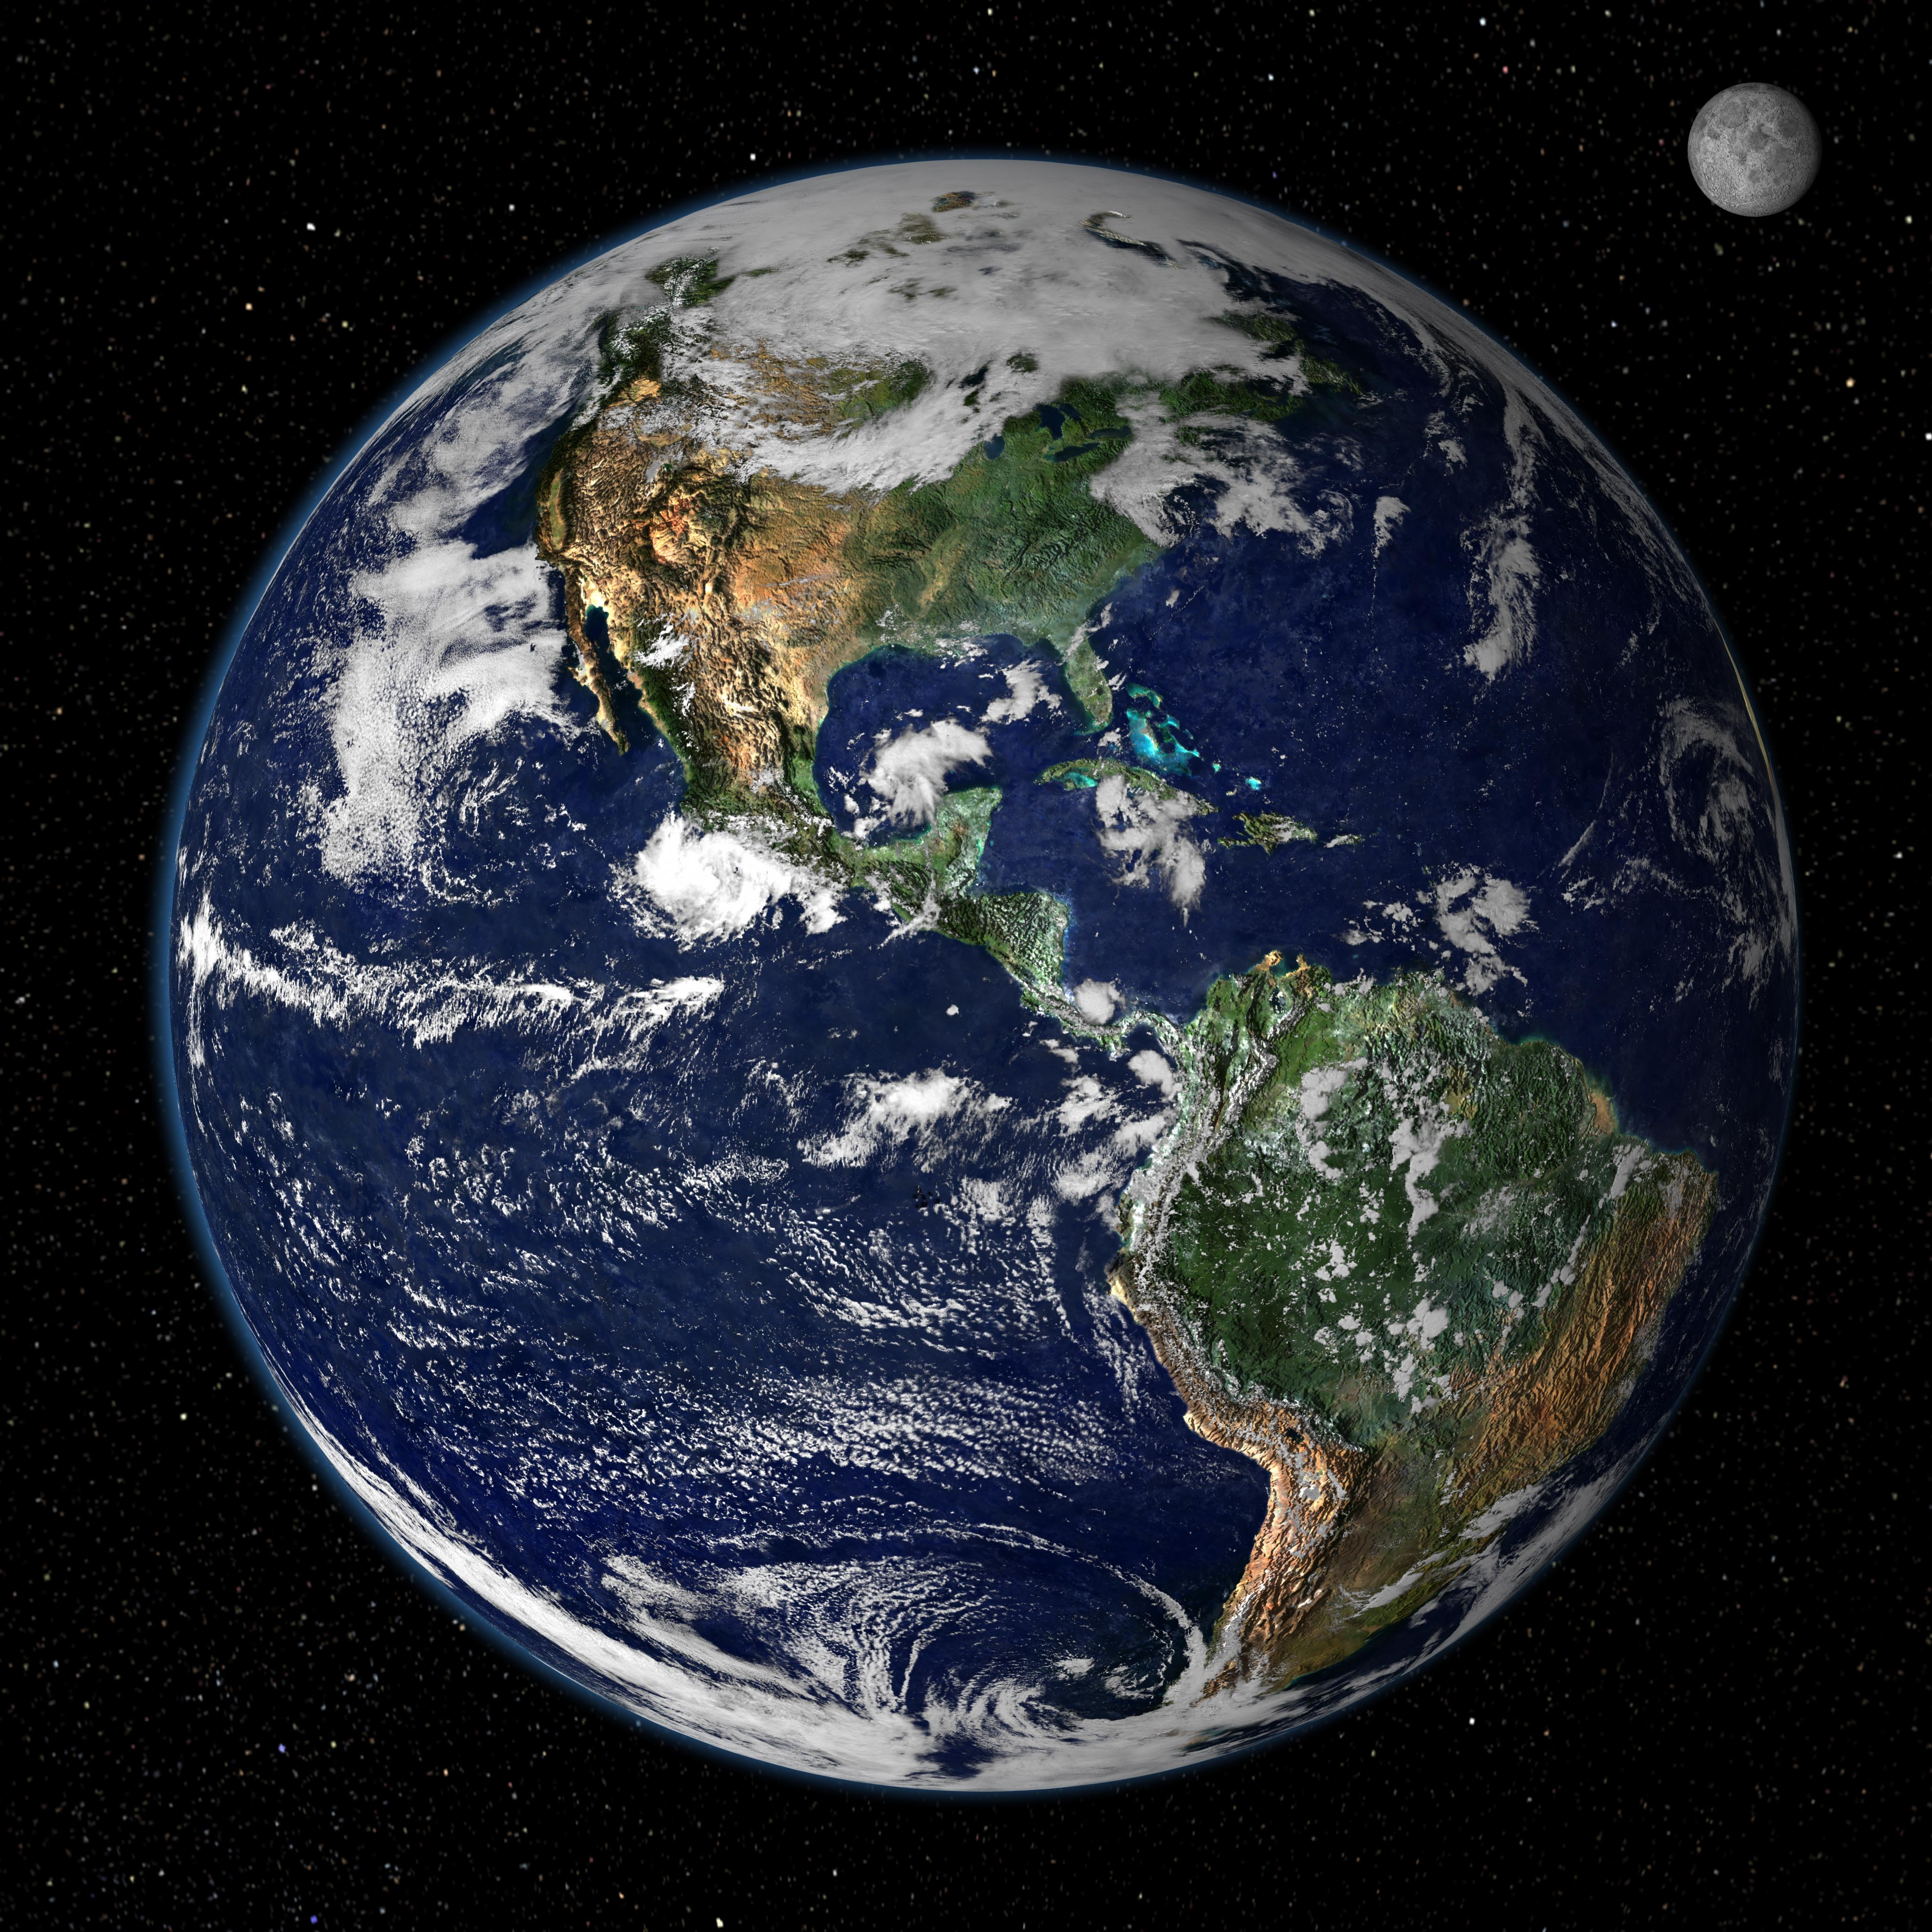
BIG Questions
What is space?
How much space does it take up?
How did it get there in the first place?
Where is Earth in space?
How did Earth become, you know, Earth?

